3장 과제

국어국문학과 2018312567 조명하

1. copy.c

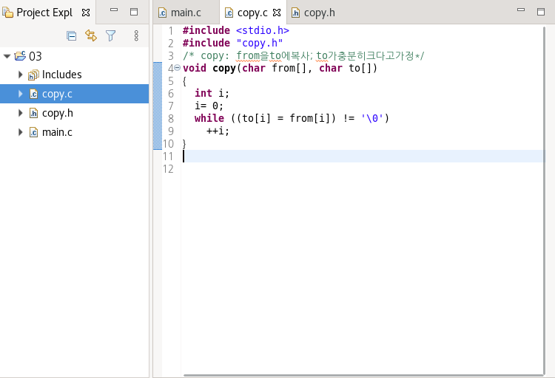

2. copy.h

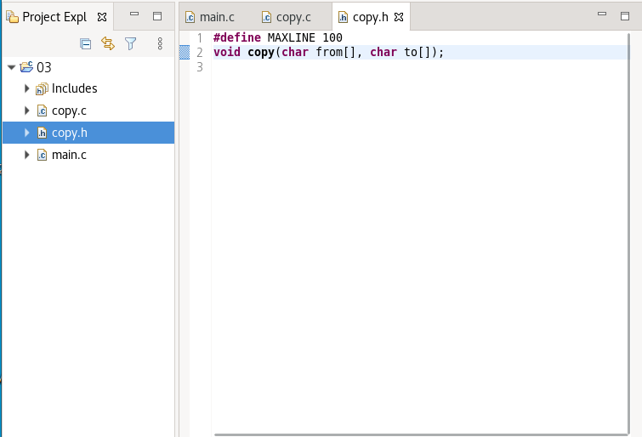

3. main.c

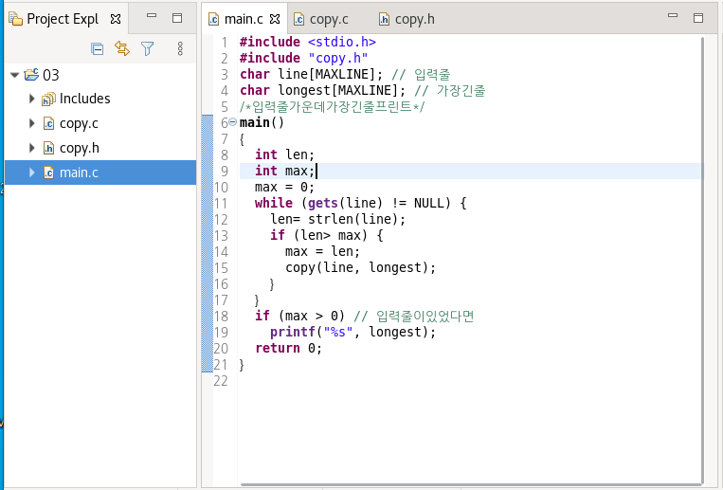

4. 터미널 로그

[chomyungha@localhost ~]$ ls

eclipse test 다운로드 바탕화면 사진 음악

eclipse-workspace 공개 문서 비디오 서식

[chomyungha@localhost ~]$ cd eclipse-workspace

[chomyungha@localhost eclipse-workspace]$ ls

03

[chomyungha@localhost eclipse-workspace]$ cd 03

[chomyungha@localhost 03]$ ls

copy.c copy.h main.c

[chomyungha@localhost 03]$ gcc -g -o main main.c copy.c

main.c: In function ‘main’:

main.c:12:2: warning: ‘gets’ is deprecated (declared at /usr/include/stdio.h:638) [-Wdeprecated-declarations]

while (gets(line) != NULL) {

^

main.c:13:8: warning: incompatible implicit declaration of built-in function ‘strlen’ [enabled by default]

len= strlen(line);

^

/tmp/ccvfxBNw.o: In function `main':

/home/chomyungha/eclipse-workspace/03/main.c:12: warning: the `gets' function is dangerous and should not be used.

[chomyungha@localhost 03]$ ./main

Hey

Happy Day

Hello

Happy Day[chomyungha@localhost 03]$ gdb main

GNU gdb (GDB) Red Hat Enterprise Linux 7.6.1-120.el7

Copyright (C) 2013 Free Software Foundation, Inc.

License GPLv3+: GNU GPL version 3 or later <http://gnu.org/licenses/gpl.html>

This is free software: you are free to change and redistribute it.

There is NO WARRANTY, to the extent permitted by law. Type "show copying"

and "show warranty" for details.

This GDB was configured as "x86_64-redhat-linux-gnu".

For bug reporting instructions, please see:

<http://www.gnu.org/software/gdb/bugs/>...

Reading symbols from /home/chomyungha/eclipse-workspace/03/main...done.

(gdb) l main

3 char line[MAXLINE]; // 입력줄

4 char longest[MAXLINE]; // 가장긴줄

5

6 /*입력줄가운데가장긴줄프린트*/

7 main()

8 {

9 int len;

10 int max;

11 max = 0;

12 while (gets(line) != NULL) {

(gdb) l

13 len= strlen(line);

14 if (len > max) {

15 max = len;

16 copy(line, longest);

17 }

18 }

19 if (max > 0) // 입력줄이있었다면

20 printf("%s", longest);

21 return 0;

22 }

(gdb) l copy

1 #include <stdio.h>

2 #include "copy.h"

3 /* copy: from을to에복사; to가충분히크다고가정*/

4 void copy(char from[], char to[])

5 {

6 int i;

7 i= 0;

8 while ((to[i] = from[i]) != '\0')

9 ++i;

10 }

(gdb) l

11

(gdb) b main

Breakpoint 1 at 0x4005c5: file main.c, line 11.

(gdb) b copy

Breakpoint 2 at 0x400634: file copy.c, line 7.

(gdb) info b

Num Type Disp Enb Address What

1 breakpoint keep y 0x00000000004005c5 in main at main.c:11

2 breakpoint keep y 0x0000000000400634 in copy at copy.c:7

(gdb) r

Starting program: /home/chomyungha/eclipse-workspace/03/main

Breakpoint 1, main () at main.c:11

11 max = 0;

Missing separate debuginfos, use: debuginfo-install glibc-2.17-317.el7.x86_64

(gdb) n

12 while (gets(line) != NULL) {

(gdb) n

Hey

13 len= strlen(line);

(gdb) n

14 if (len > max) {

(gdb) n

15 max = len;

(gdb) n

16 copy(line, longest);

(gdb) n

Breakpoint 2, copy (from=0x60104f <line> "Hey", to=0x601045 <longest> "")

at copy.c:7

7 i= 0;

(gdb) n

8 while ((to[i] = from[i]) != '\0')

(gdb) n

9 ++i;

(gdb) n

8 while ((to[i] = from[i]) != '\0')

(gdb) n

9 ++i;

(gdb) n

8 while ((to[i] = from[i]) != '\0')

(gdb) n

9 ++i;

(gdb) n

8 while ((to[i] = from[i]) != '\0')

(gdb) n

10 }

(gdb) n

main () at main.c:12

12 while (gets(line) != NULL) {

(gdb) n

Happy Day

13 len= strlen(line);

(gdb) n

14 if (len > max) {

(gdb) n

15 max = len;

(gdb) n

16 copy(line, longest);

(gdb) n

Breakpoint 2, copy (from=0x60104f <line> "Happy Day",

to=0x601045 <longest> "Hey") at copy.c:7

7 i= 0;

(gdb) n

8 while ((to[i] = from[i]) != '\0')

(gdb) n

9 ++i;

(gdb) n

8 while ((to[i] = from[i]) != '\0')

(gdb) n

9 ++i;

(gdb) n

8 while ((to[i] = from[i]) != '\0')

(gdb) n

9 ++i;

(gdb) n

8 while ((to[i] = from[i]) != '\0')

(gdb) n

9 ++i;

(gdb) n

8 while ((to[i] = from[i]) != '\0')

(gdb) n

9 ++i;

(gdb) p to

$1 = 0x601045 <longest> "Happy"

(gdb) p from

$2 = 0x60104f <line> "Happy Day"

(gdb) n

8 while ((to[i] = from[i]) != '\0')

(gdb) n

9 ++i;

(gdb) n

8 while ((to[i] = from[i]) != '\0')

(gdb) n

9 ++i;

(gdb) n

8 while ((to[i] = from[i]) != '\0')

(gdb) n

9 ++i;

(gdb) n

8 while ((to[i] = from[i]) != '\0')

(gdb) n

9 ++i;

(gdb) p to

$3 = 0x601045 <longest> "Happy Day"

(gdb) n

8 while ((to[i] = from[i]) != '\0')

(gdb) n

10 }

(gdb) n

main () at main.c:12

12 while (gets(line) != NULL) {

(gdb) n

Hello

13 len= strlen(line);

(gdb) n

14 if (len > max) {

(gdb) n

12 while (gets(line) != NULL) {

(gdb) n

19 if (max > 0) // 입력줄이있었다면

(gdb) n

20 printf("%s", longest);

(gdb) n

21 return 0;

(gdb) n

22 }

(gdb) n

0x00007ffff7a2f555 in __libc_start_main () from /lib64/libc.so.6

(gdb) n

Single stepping until exit from function __libc_start_main,

which has no line number information.

Happy Day[Inferior 1 (process 3526) exited normally]

(gdb) quit

[chomyungha@localhost 03]$